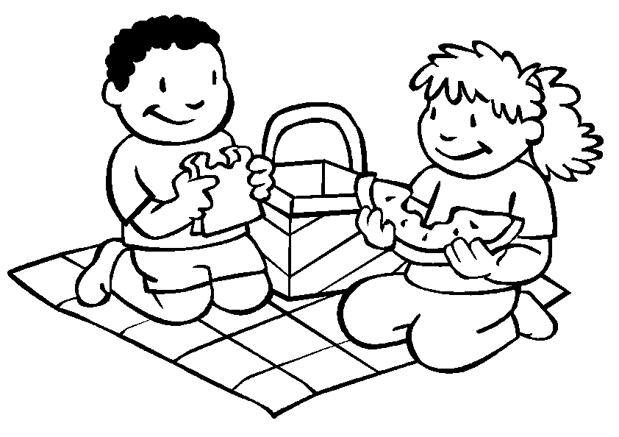
L _ _ _ each other…
take _ _ _ _ _ _ _ in honouring each other.
Luke 6:31

